**New Things Needed In Next 10 days**

**Bunch Of URL :**

1. Location wise job Search (eg: jobs in delhi )
2. Skills Wise Job Search (eg: .net developer)
3. Designation wise job search (Eg : Manager job in delhi )
4. Job By company ( Eg : Accenture Job)

Searching job by url the job the job listing name should be also changed according to the search

**Eg:** ( .net developer / listing should be also .net developer)

**Category in job:**

1. Marketing
2. Digital Marketing
3. Law
4. VlSI
5. Graphic designer
6. Ecommerce
7. Telecom
8. Content writing
9. Printing packaging
10. Travel tourism
11. Textile garments fashion
12. Logistics courier transportation
13. Security detective services
14. Architecture interior design
15. Oil gas engineering
16. Production maintenance
17. Supply chain purchase inventory
18. Insurance
19. Export import trading

**Category in Voices:**

1. Resume tips
2. Surveys
3. Social Media
4. Recruiter Tips
5. Job Search Techniques

**SEO issues : (Page Speed )**

* The page Completely load but user can’t do any thing on the page( Need To be done urgently)
* Image optimization
* Enable Compression

1. Desktop:

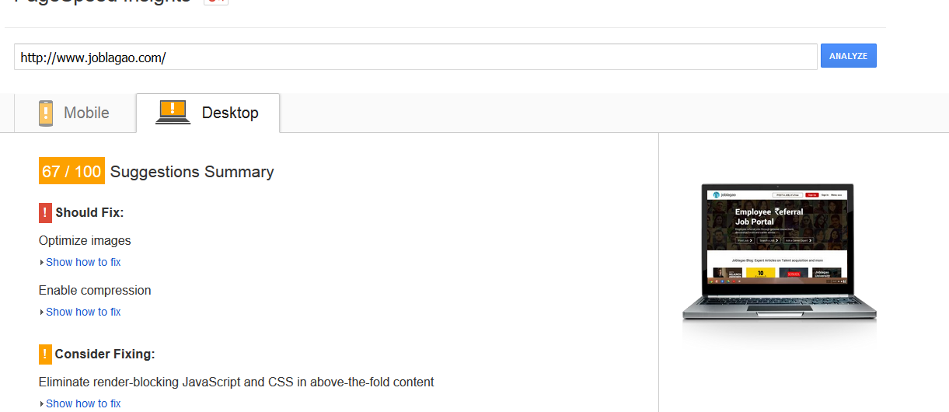

**2) Phone :**

1) Eliminate Render Blocking Java Script and CSS

2) Image Optimization

3) Minify Java Script

4)Minify HTML

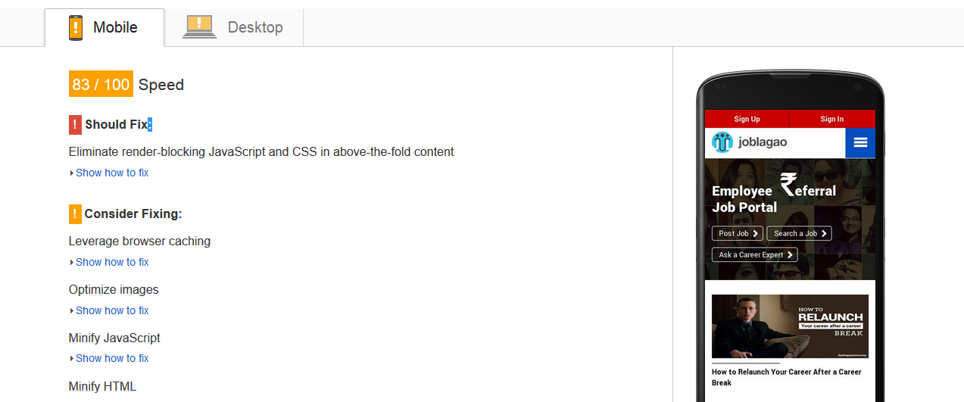

**For Sign up we need this feature urgently :**

* To provide authentication to add schema attribute in HTML element on voices and job
* For apply job, there should be a form like Indeed we not just need log in (Eg : we can put two option there like **1) log in to apply 2) register to apply**
* To add meta description on each web pages
* To add categorized jobs on Home page
* Main job title should be in h1
* About company Page it should be in h1
* To create different login poster to place between the voice so that we can get more users log in like for more related article please register.
* Job search like .net developer in noida search ( title should come .net developer in noida in h1 )
* Admin Pannel with proper search for jobs, article and users .
* Create a new landing page for free job posting ( targeting free job posting) and after that we can promote that landing page so that we can get more users and more organic job.
* In user profile the profile name should in h1 and the location should me h2 .
* User Schema Should also be applied .